Web Development

Nicholas Randles

B00058026

Group 4

Screenshots of Web Page

**Home page**

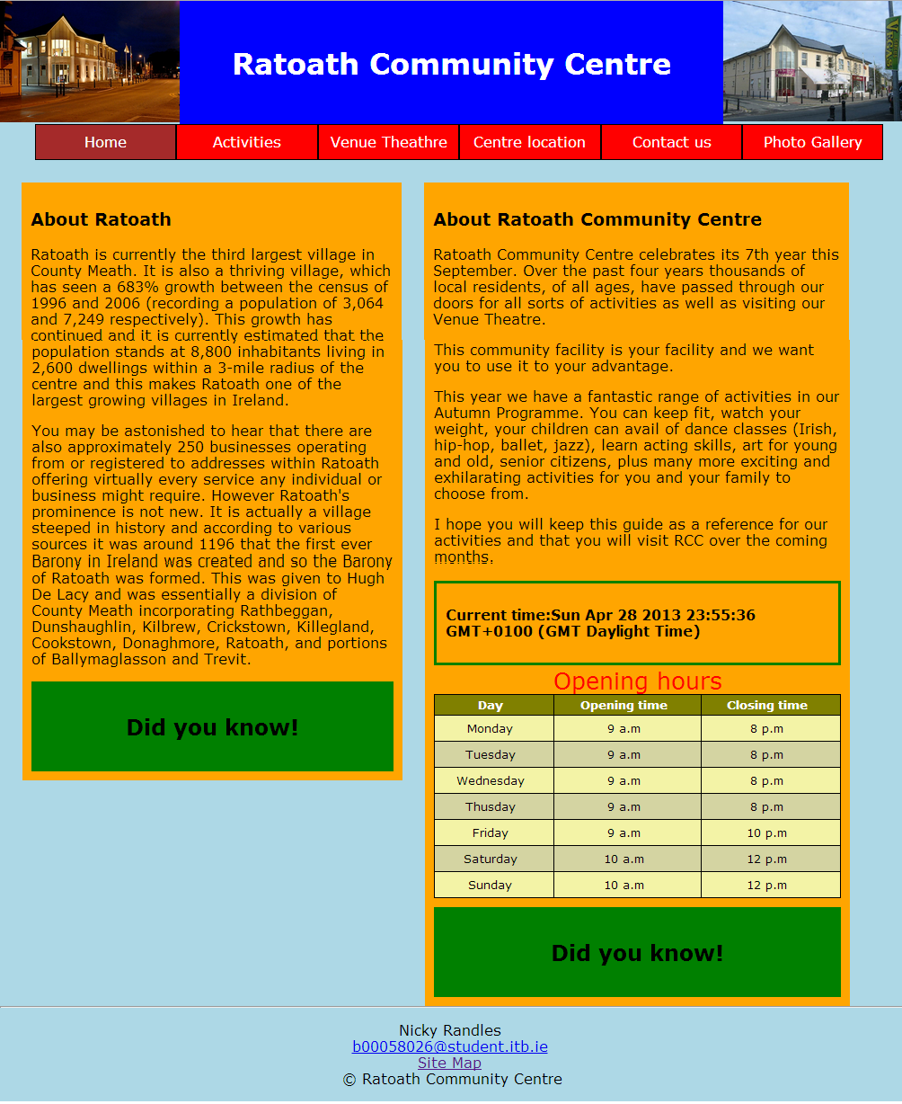

**Activity page**

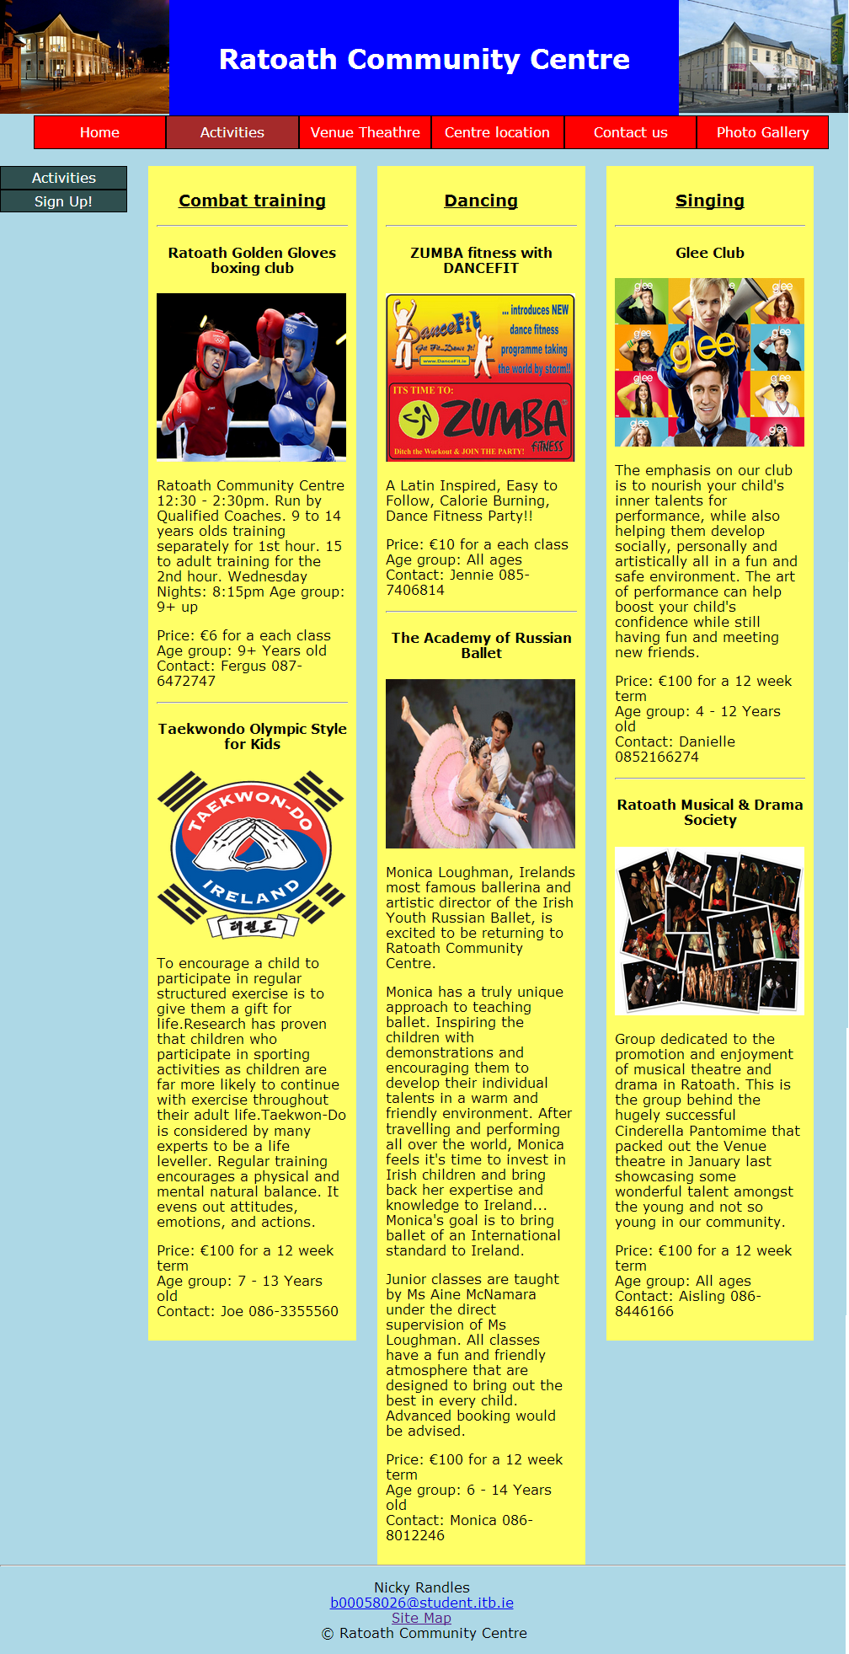

**Venue theathre page**

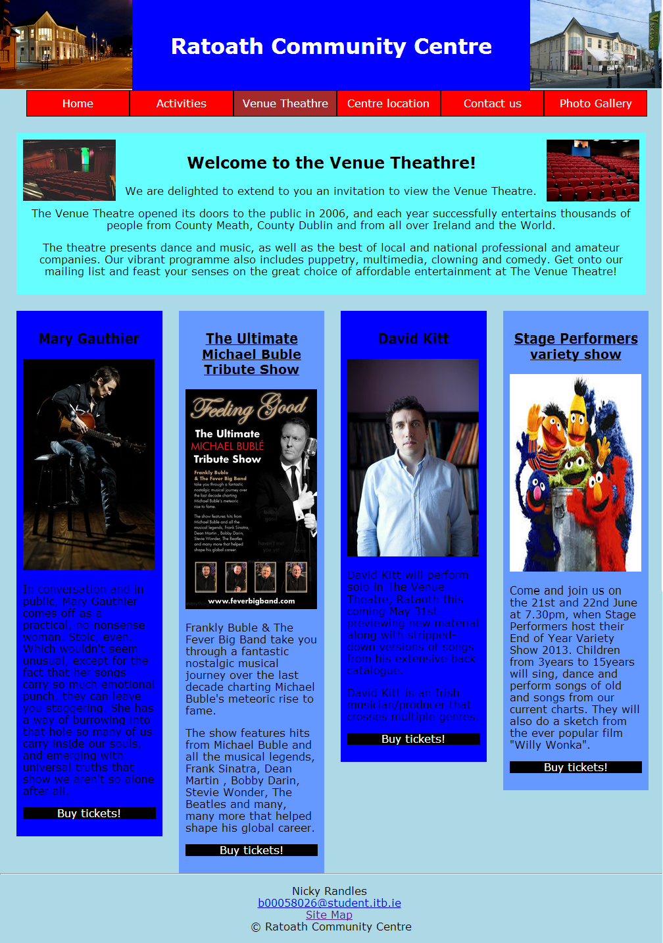

**Home Page**

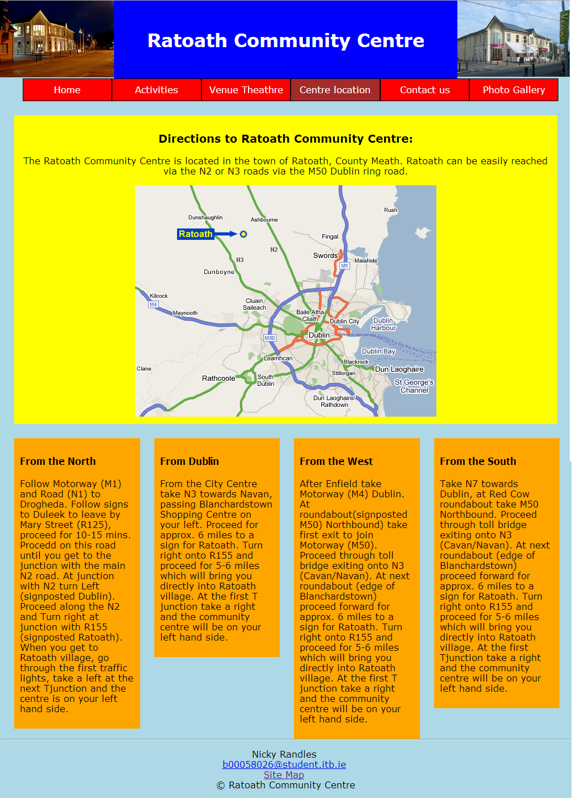

**Contact us page**

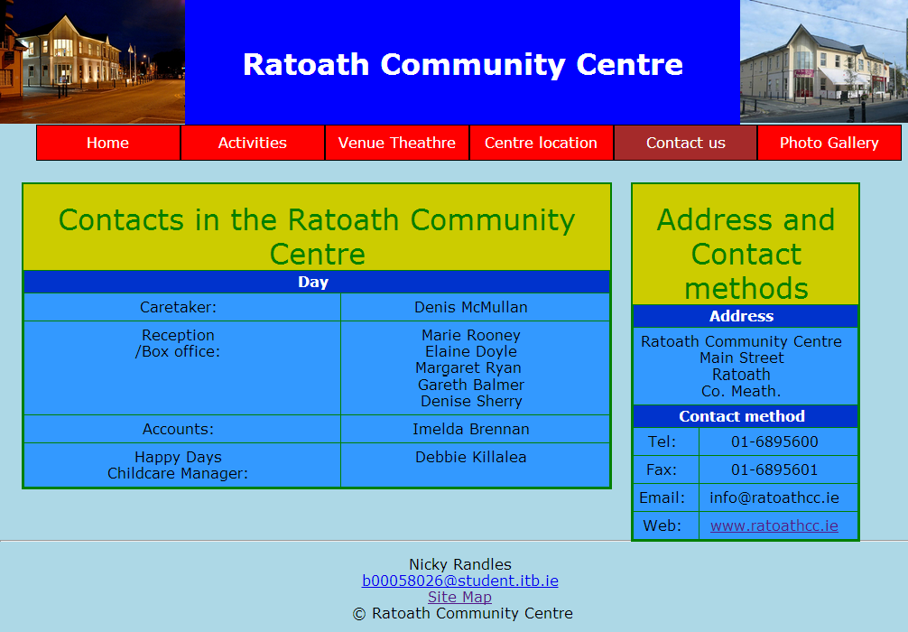

**Photo gallery page**

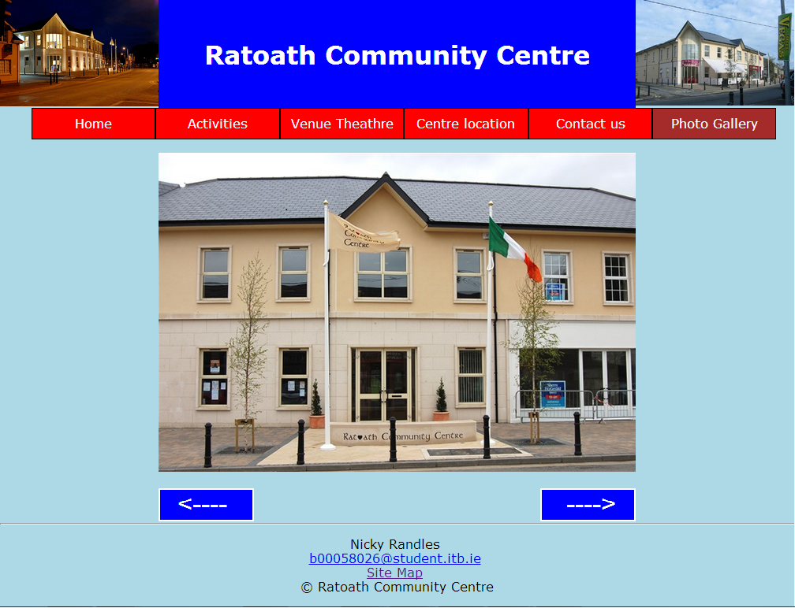

**Site map page**

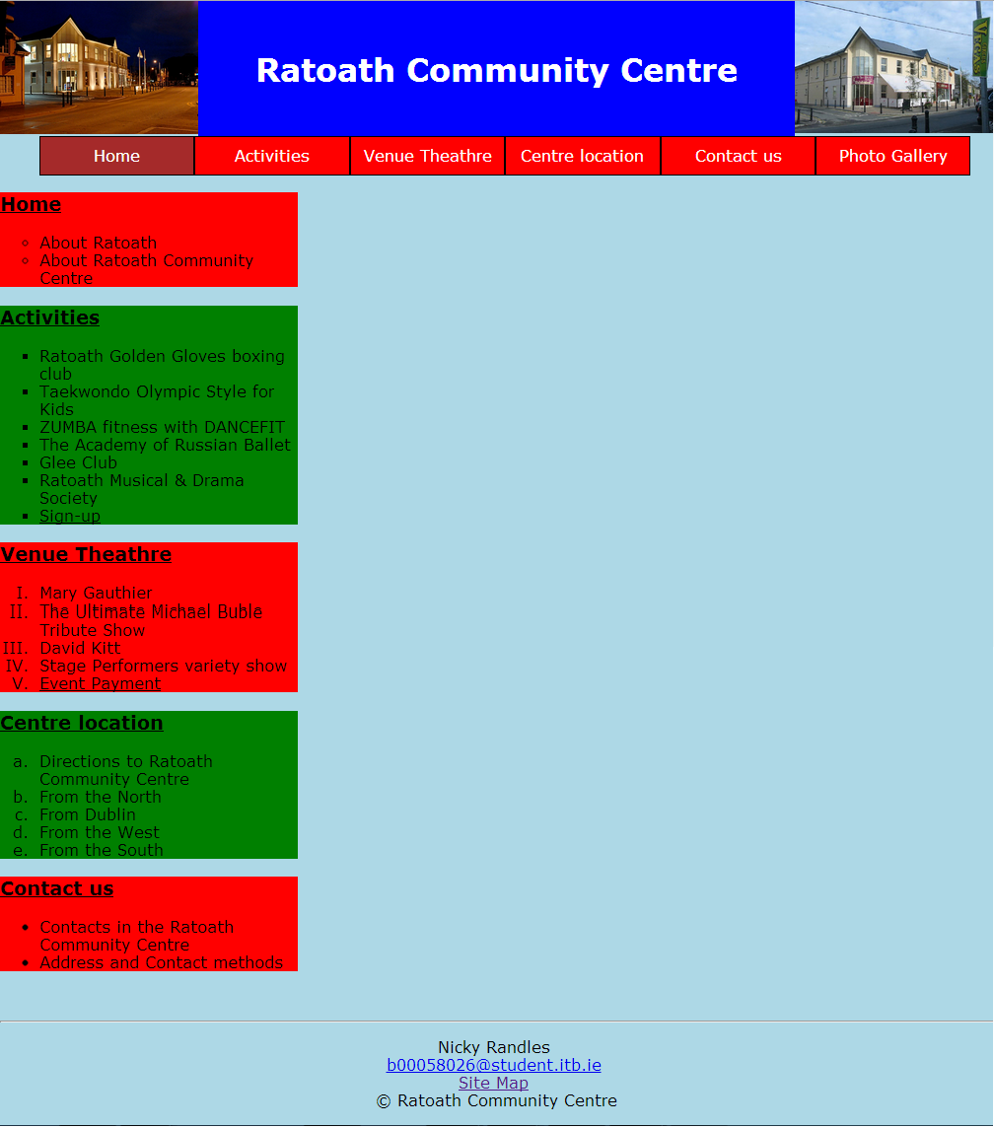

**Activity payment page**

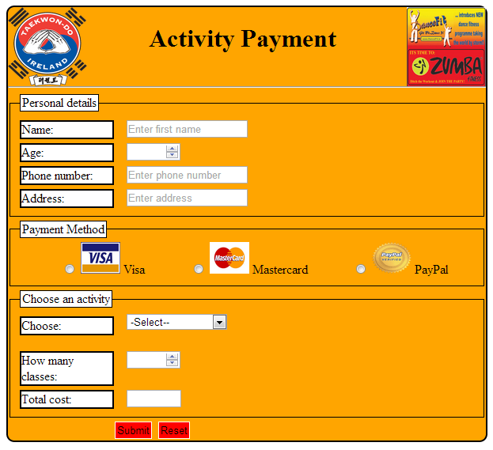

**Event payment page**

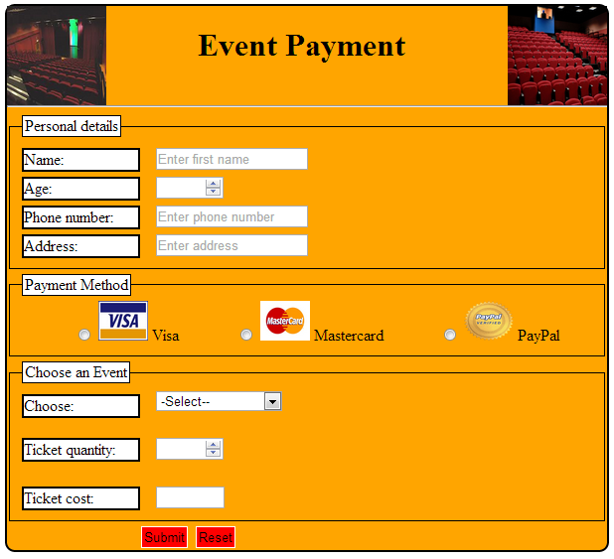

**Payment confirmation page**



Website

Features

**Features of website**

* The home page has a two column liquid layout.
* The activity page has a three column liquid layout.
* The contact us page has a two column, fixed width, centred layout.
* The venue theathre and centre location pages both have four columns.
* Each page has a consistent header, footer and navigation bar.
* The navigation bar is linked to all the pages and shows the current page.
* The footer contains my student name and email contact details on all pages.
* The style sheets are imported externally by the “import” command on all pages.
* I used css classes, divs and HTML5 markups on all pages.
* The images on the venue theatre page have been positioned with the float feature. They have been floated around the header and have been resized.
* I have made three styled tables. One on the homepage and two on the contact us page.
* I have displayed a floating side bar on the activity page.
* I have displayed 5 differently styled lists on the site map page.
* I have a number of dynamic elements using JavaScript. I have the time/date and two hide & reveal features on the home page. I have two rollover features on the venue theatre page. I have calculation features on the event payment and activity payment pages. I also have used the slideshow feature on the photo gallery page.
* I have used the properties of the box model on all pages. I have used paddings, margins and borders on all pages.
* I have elements on the contact us page that are in fixed positions.
* I have two forms that are styled and aligned using css.
* Both forms show five images.
* All pages include doctype.

Html and CSS Validation

**Html validation**

All of my html pages validated on w3c validator

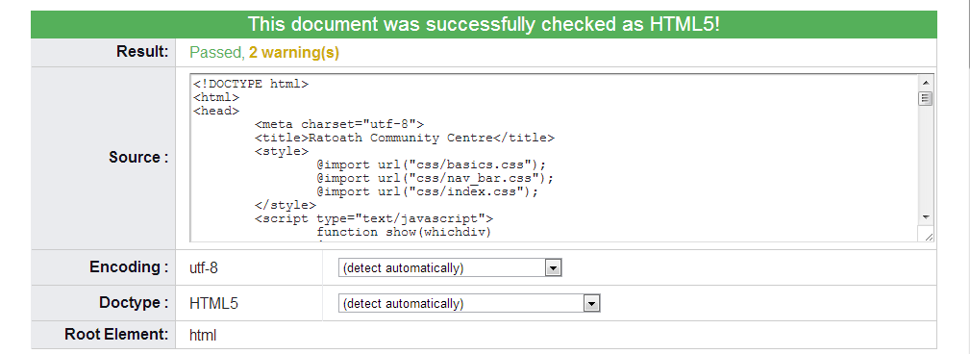

**CSS validation**

All of my CSS pages validated on w3c CSS validator

